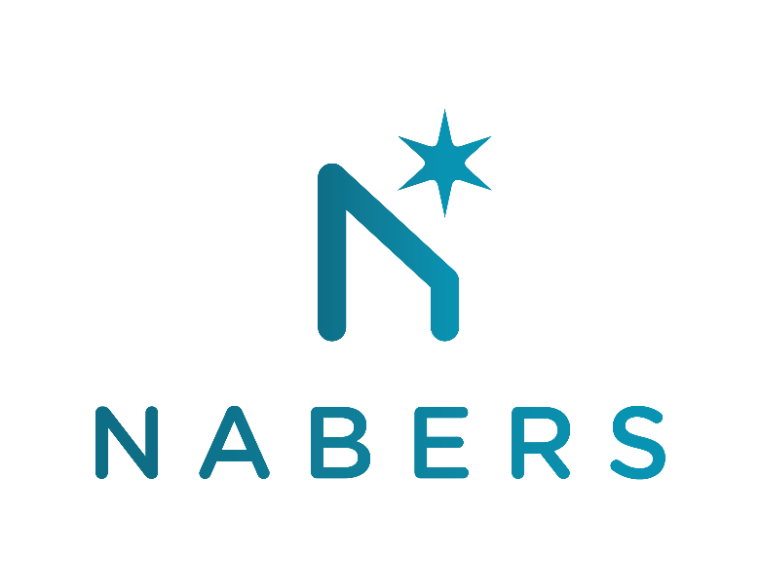

Recognising uptake of renewable energy
Consultation response form

Thank you for responding to this consultation, part of the Future of NABERS Energy project.
Please provide your feedback in this document, and return in word (.docx) format to nabers@environment.nsw.gov.au.
Please return your responses by COB Monday 25th October 2021.

NABERS is administered by the NSW Department of Planning, Industry and Environment
Organisation: Enter your organisation’s name here

Focus Question – Section 4.3 | Comments
- Have you been using the NABERS Energy with GreenPower? How have you been using this tool? | Enter your responses to the questions in this table
- Do you support retiring the NABERS Energy with GreenPower rating tool? Why/why not?
- What are the consequences of retiring this tool? Are these mitigated by the introduction of the Renewable Energy Indicator?
- Would a transition phase where the NABERS Energy with GreenPower rating is still included in the Rating Report (and not as a separate rating certificate) be useful to mitigate these risks? If so, how long should this transition be?
- Do you have any other feedback or suggestions that could help in the success of this implementation?
If you have any other feedback or context related to this consultation that you would like to provide, please add it here:

